BY ANTHONY J. SEKLAWI

**NUTRITION**

**GUIDE**

for a healthier life



# **Basics of nutrition:**

There are two main types of nutrients, macronutrients and micronutrients. The three main categories of macronutrients include carbohydrate, protein, and fat. The two types of micronutrients are vitamins and minerals, and these are extra molecules that cells need to make energy. Let's take a look at the three groups of macronutrients we mentioned.

## 

## 

## **Macronutrients:**

The three main categories of macronutrients include:

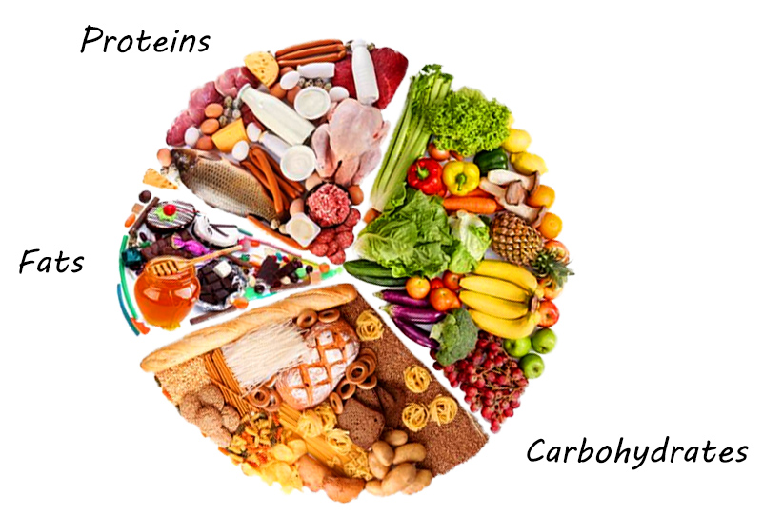

**3-fats**

**1-carbohydrate**

**2-protein**

Figure 2

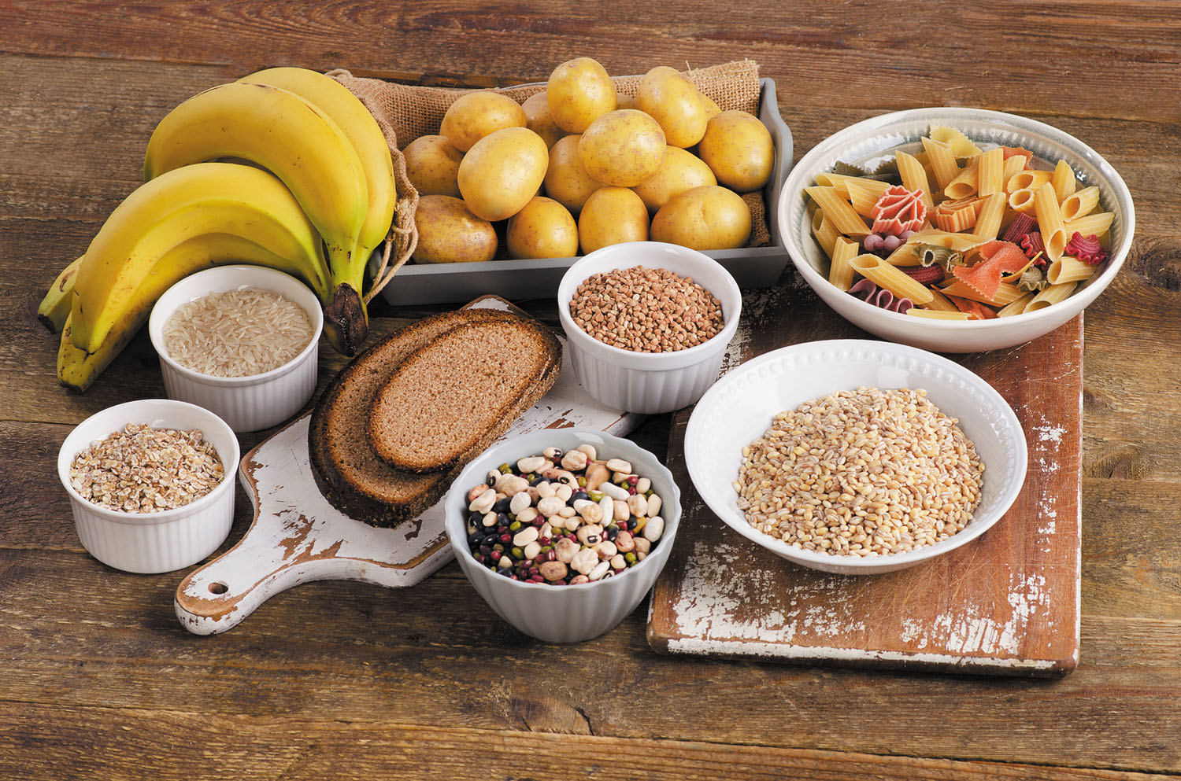

**1-Carbohydrates:**

**Carbohydrates** are a type of macronutrient used for quick energy in cells. The basic unit of carbohydrates is a monosaccharide. An example of a monosaccharide is **glucose** or sugar. Glucose can be by itself, or assembled into long chains to make things like starch, which can be found in potatoes. Have you heard of the athletic term, carbo-loading? Athletes load up on carbohydrates before a big race to give themselves a store of quick energy. Carbohydrates have gotten a bad rap lately, but everyone needs carbs! It is important to eat a balanced diet with all the major nutrient categories. Foods that contain carbohydrates include grains, bread, pasta, potatoes, fruits and sweets such as soda and candy. 1 gram of carbohydrate= 4 calories

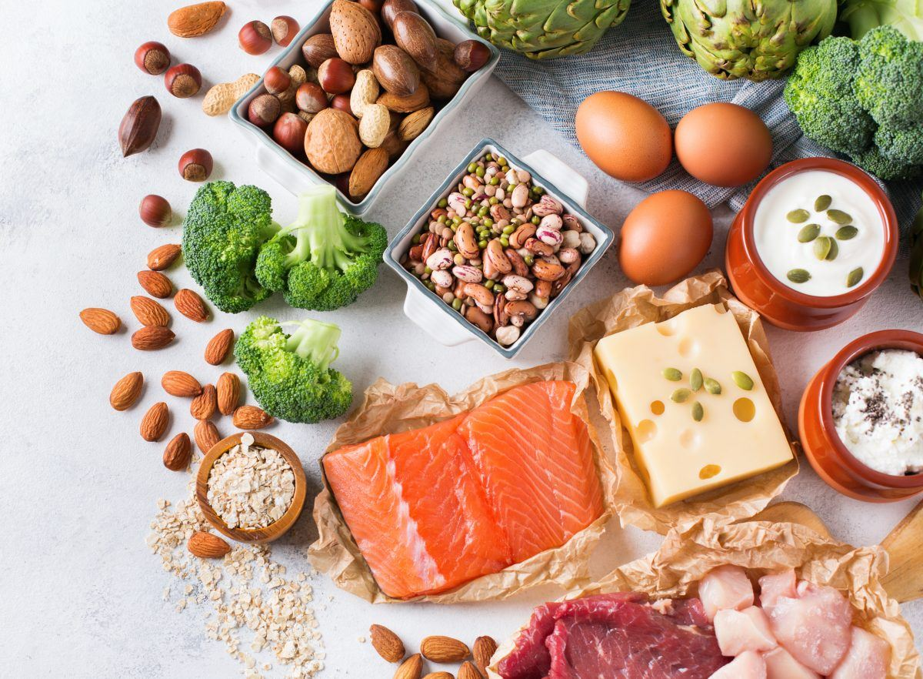

**2-Proteins:**

Proteins are a macronutrient that the cells in your body use for structure. Protein is very important for building tissues, such as muscle. Muscle is mainly made up of proteins. Think how bodybuilders are always eating plain chicken and protein bars - they're trying to build their muscles by getting lots of protein in their diet! Proteins are made from smaller monomers called amino acids. There are twenty amino acids that make up all the kinds of protein your body needs.

1 gram of protein= 4 calories

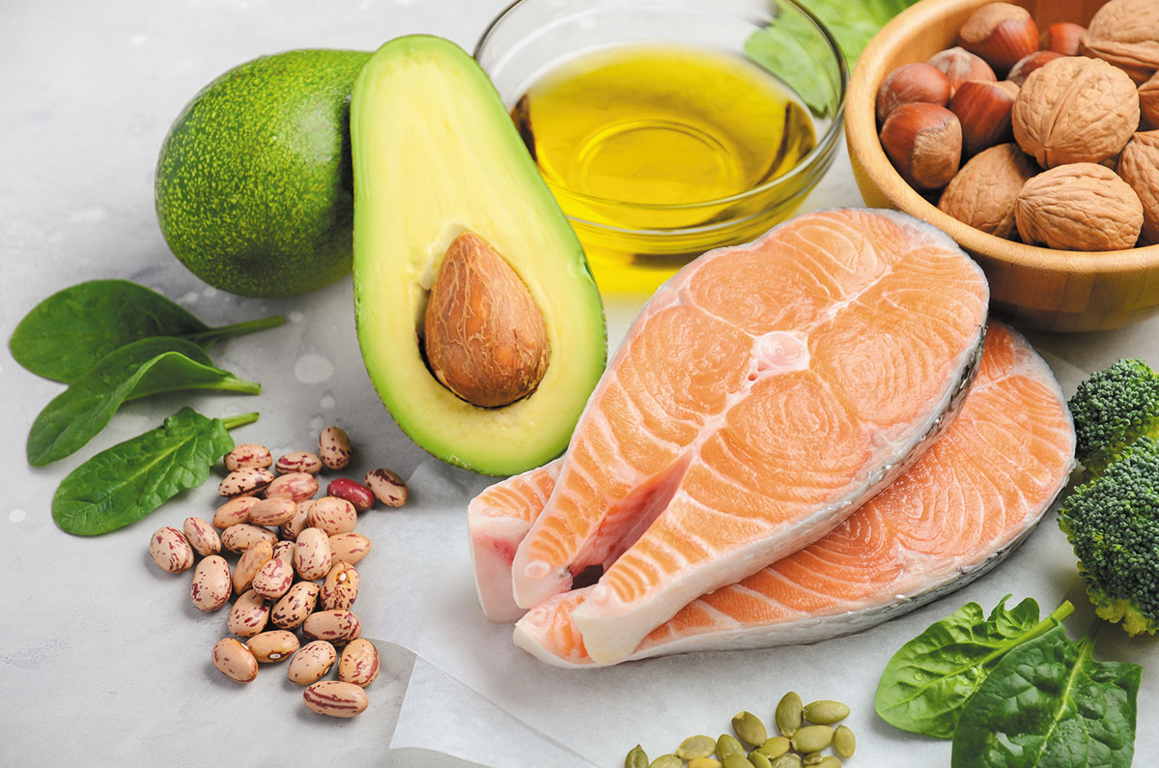

**3-Fats:**

Fats are called lipids and are a macronutrient in your body that stores energy. Fats have long chains of carbon and hydrogen, which store lots of energy in the chemical bonds. Fats are important in our body to cushion organs, protect our cells, and send signals in the form of hormones around our body. Foods that are rich in fats are butter and oil.

1 gram of fat= 9 calories

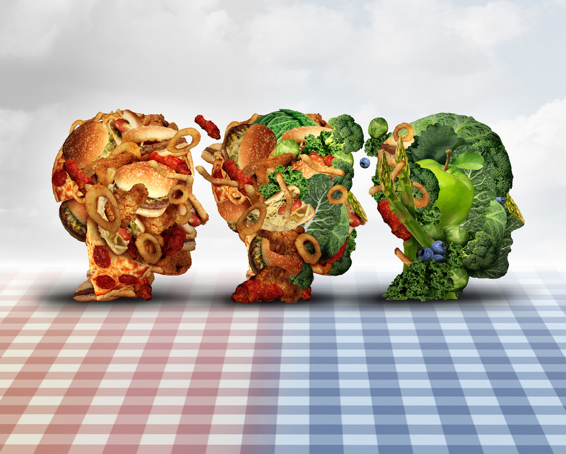

### **healthy food choices:**

* organic eggs
* wild salmon
* grass fed beef
* Greek yogurt
* broccoli
* spinach
* natural peanut butter
* almond
* olive oil
* avocado

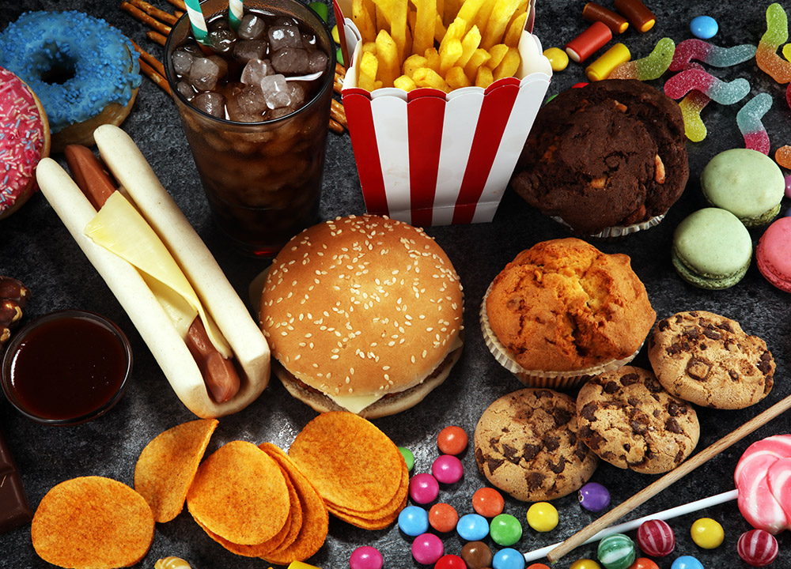

#### **unhealthy food choices:**

* vegetable oil
* fructose corn syrup
* chips
* processed cheese
* soft drinks
* alcohol
* sausage
* and the list goes on…

##### **how to read nutrition facts label:**

|  |
| --- |
| **Nutrition Facts** |
| Serving size 1 cup (158 g)  Servings per container 2 |

1. start here

|  |
| --- |
| Amount per serving |
| **Calories**  300 |

1. check calories

|  |
| --- |
| **Total fats** 13g |
| Trans fats 3g |
| Saturated fats 4g |

1. limit these

nutrients

|  |
| --- |
| **Dietary fibers 2g** |
| **Protein** 18g |
|  |

1. get enough of

these nutrients

**Contents:**

Basics of nutrition: 1

Macronutrients: 2

**healthy food choices:** 6

**unhealthy food choices:** 7

**how to read nutrition facts label:** 8

**list of table**

Figure 2 2